Name : Anupam Kunwar
Reg : 19BCE1369

Q1.

import java.util.Scanner;

public class square_root {

public static void main(String[] args) {
double squareRootOfNumber = 0.0;
double number;
Scanner in = new Scanner(System.in);
System.out.println("Enter the number: ");
number = in.nextDouble();
squareRootOfNumber = Math.sqrt(number);
if (number < 0) {
throw new ArithmeticException("Can't take square root of negative number");
}
System.out.format("Square root of number entered is %.2f %n", squareRootOfNumber);
}

}

Output :

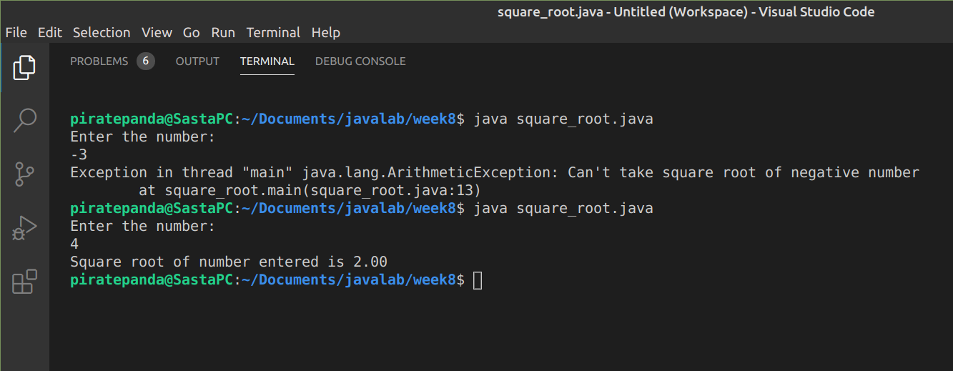

Q2.

import java.util.Scanner;

public class parseDouble {
public static void main(String[] args) {
Scanner in = new Scanner(System.in);
double num;
try {
System.out.print("Enter a number : ");
num = Double.parseDouble(in.nextLine());
} catch (NumberFormatException e) {
num = 0;
System.out.println("Invalid input. Number entered should be a number in double type");
}
System.out.println(num);
}
}

Output :

